# Experimental Description:

The experiment was performed in the Sandia Turbulent Diffusion Flame Facility. A schematic of the experimental setup is shown in Figure 2.1(a). The flow configuration consists of a high-velocity central jet of fuel surrounded by a coflowing airstream. Flow rates are determined from the measured pressure drop across a calibrated venturi meter located upstream of the test section. A honeycomb section located upstream of the contraction cone and a 9:1 area ratio across the contraction cone provide a uniform velocity across the test section entrance with a measured inlet turbulence level of 0.4%. The fuel nozzle is located at the upstream end of the test section and is aligned with the test section centerline. The fuel jet inside diameter D is 5.2 mm with the jet exit preceded by a 2-m length of straight tubing. The test section has a 30-cm square cross section and is 200 cm long. Optical access is provided through the removable glass walls of the test section. The test section and contraction cone are mounted on a traversing mechanism driven by stepping motors to provide positioning in three directions. This allows the optical diagnostics to remain fixed and simplifies the alignment procedure. The propane jet bulk velocity uj in the present investigation was 53 m/s, giving a Reynolds number based on the jet exit diameter Re of 68,000. The coflowing air velocity uco was 9.2 m/s, giving a ratio of jet to coflow air velocity of 5.76. A boundary layer was also measured along the outer edge of the jet pipe with a thickness of approximately 0.3 jet diameters at the exit plane[2].

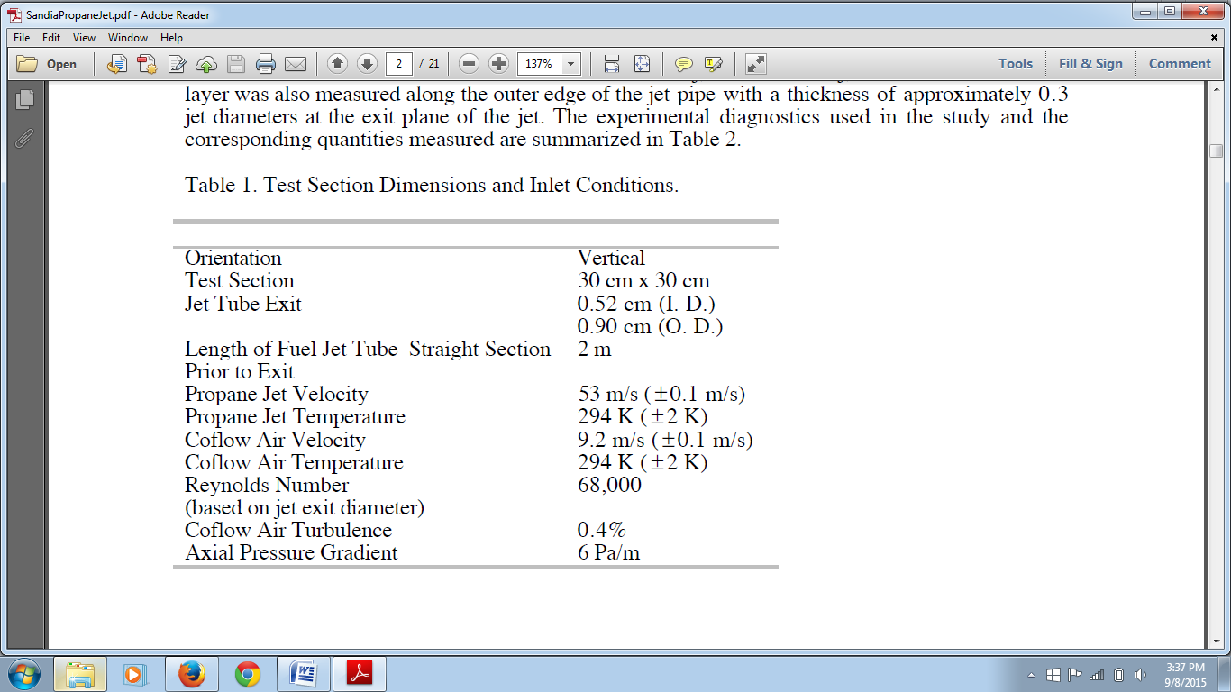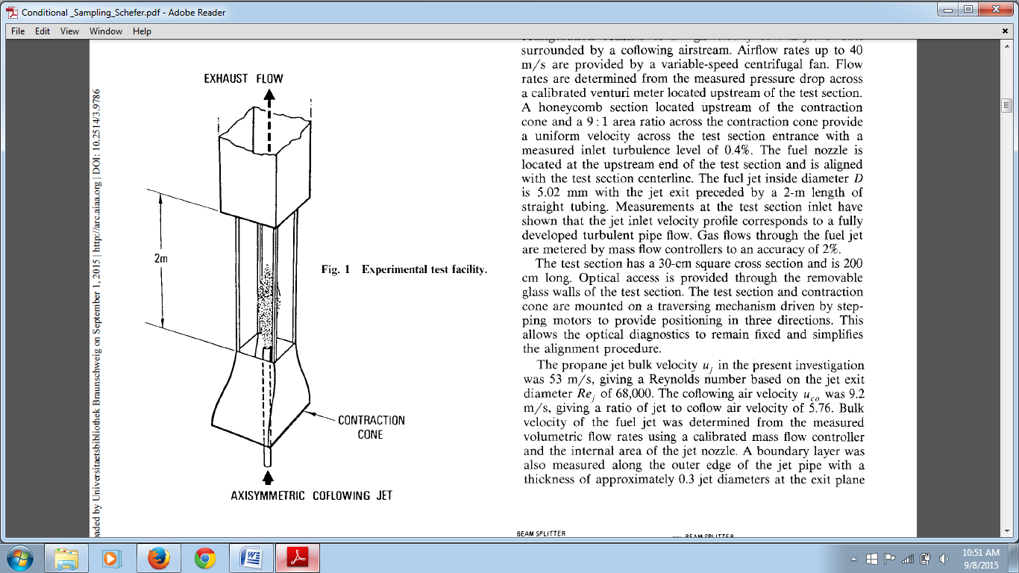

AXISYMMETRIC FUEL JET

Figure 2.1(a) & Table 1

The experimental data for the mean and rms mixture fraction was measured using the Rayleigh scattering technique, detailed information about which can be found in [1]. And the measurements for the mean and rms velocity (axial and radial components) has been measured using laser Doppler velocimetry (LDV) twice, once by seeding the jet and once by seeding the co-flow[2].

Figure 2.1(b) shows the 2D axisymmetric experimental setup. The dimensions for the same are mentioned in table below.

Figure 2.1(b)

|  |  |  |  |  |  |  |
| --- | --- | --- | --- | --- | --- | --- |
| Parameter | L | L2 | d | DCoflow | HB | H |
| Values(cm) | 30 | 5 | 0.26 | 14.55 | 0.19 | 15 |

Table 2

Characteristic Length and Diameter:

Length of test section = L

Length of bluff body = L2

Propane jet inlet radius = d (in reference used as ‘D’)*

Co-flow air channel width = DCoflow

Height of the bluff body = HB

Height of the test section = H

**\***Note: Here d = 0.26 [cm] is considered as the radius of the jet for the axisymmetric domain. Consequently the Propane jet diameter D used in the original references for the non-dimensional variables X/D and Y/D is D = 0.52 [cm].

Experimental data has been provided for locations (X/D) = 4, 15, 30, 50 downstream the jet exit plane. Also the data has been provided for location y/D = 0 (centerline), D = 0.52 cm (jet exit diameter) is used to normalize the axial and radial locations. The measured flow field quantities are:

1. Mean velocity component (axial & radial), U, V
2. Rms fluctuating velocity components, (u’, v’)
3. Mean mixture fraction, f
4. Rms fluctuating mixture fraction, f’

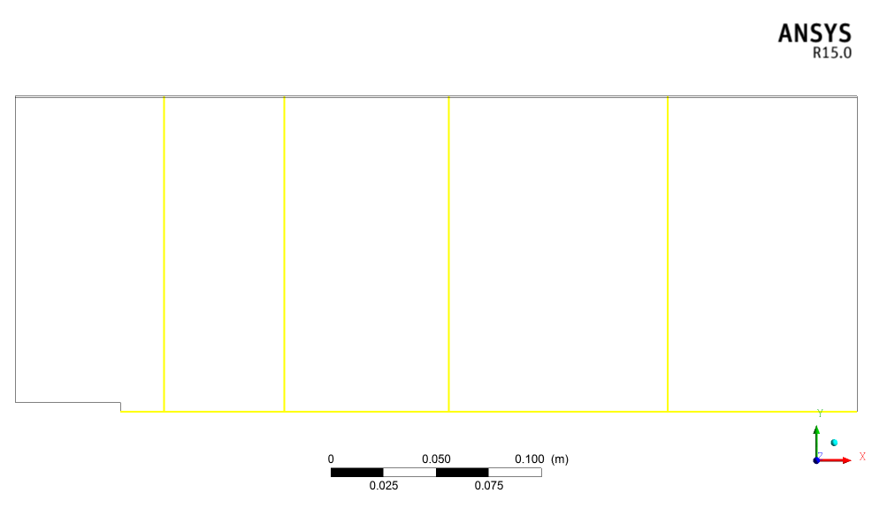

Y/D = 0

X/D = 30

X/D = 50

X/D = 15

X/D = 4

Figure 2.1(c)